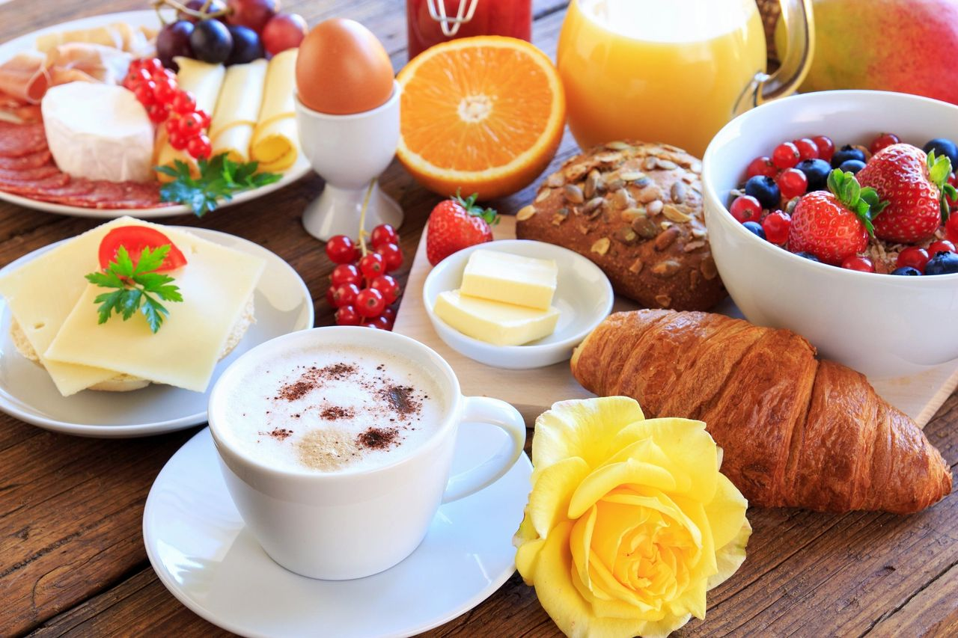 | Brunch Package Proposal  Thank you for considering Kitchen Klassifieds Catering and Events. Please revies the proposal and let us know if you have any question. If you need to make any changes to include dietary needs of your guest, please let us know and substitution can be made.  Shannon Brown Director or Sale and Marketing

Emmy Awards 35.99

Includes: coffee, assorted tea, juice, and water

Signature Dish

Shrimp and Grits

Choice of:(Pick 1)

Pancakes, Waffles, Deep Dish French Toast

Choice of: (Pick 1)

Cream of Wheat or Oatmeal

Choice of: (Pick 2)

Bacon, Sausage, Turkey Bacon, Turkey Sausage Corn Beef Hash,

Biscuits and Gravy, Scrapple

Choice of Eggs:

Scrambled or Boiled

Fried Potatoes

Signature Fruit Display

Taxes, Fees, and Gratuity are not included

The Oscars 53.99

Includes: coffee, assorted tea, juice, water, Mimosas

Signature Dish

Shrimp and Grits or Chix Waffle

Choice of:(Pick 1)

Pancakes, Waffles, Deep Dish French Toast

Choice of: (Pick 1)

Cream of Wheat or Oatmeal

Choice of: (Pick 3)

Bacon, Sausage, Turkey Bacon, Turkey Sausage Corn Beef Hash,

Biscuits and Gravy, Scrapple

Choice of Eggs:

Scrambled or Boiled

Choice of: (Pick 1)

Fried Potatoes w/ Cheese, Peppers and Onions or Home fries

Signature Fruit Display

Assorted Pastries

Taxes, Fees, and Gratuity are not included

World Premiere 70.99

Includes: coffee, assorted, tea, juice, water, mimosas, and sangrias

Signature Dish(s)

Shrimp & Grits and Chicken & Waffles

Choice of:(Pick 1)

Pancakes or Dish French Toast

Choice of: (Pick 1)

Cream of Wheat or Oatmeal

Choice of: (Pick 4)

Bacon, Sausage, Turkey Bacon, Turkey Sausage Corn Beef Hash,

Biscuits and Gravy, Scrapple

Choice of Eggs:

Scrambled or Boiled

Potatoes

Fried Potatoes w/ Cheese, Peppers and Onions or Home fries

Signature Fruit Display

Full Charcuterie Graze

Assorted Pastries

Taxes, Fees, and Gratuity are not included

ADD-ONS

Yogurt Parfait Bar w/ topping

Omelet Station

Waffle Bar

Coffee/Cocoa Bar

Fried Chicken

Grilled Salmon

Lamb Chops

New York Strips

Fried White Fish

BRUNCH BUFFET

Prices for 10-15 guests (Additional fees over 15)

$2200 per brunch party

Full Table-scape + Bouquet floral centerpiece

Cloth Napkins + Crystal Glassware

(DOES NOT INCLUDE TABLES AND CHAIRS)

1. Pancakes, Deep Dish French Toast, Waffles (Pick 2)

2. Bacon, Turkey Bacon, Sausage, Turkey Sausage, Ham, Biscuits &Gravy (Pick 3)

3. Shrimp & Grits

4. Salmon Cakes, Fried Chicken (Pick 1)

5. Eggs (Scrambled/Boiled

6. Fried Chopped Potatoes

7. Full Fruit and Cheese Charcuterie Graze

8. Assorted Pastries

Mimosa & Sangrias Included

Taxes, Fees, and Gratuity are not included

